Lab No. 08:
Shaping Tools (Weld, Trim, Intersect, and
Combine)
Objective:
Understand the fundamental operations of vector shape manipulation tools in CorelDRAW (Weld, Trim, Intersect, Combine).

THEORETICAL BACKGROUND / CONCEPTS
In vector graphic design software like CorelDRAW, complex shapes are created by combining simple primitive shapes using Boolean-like operations known as Shaping Tools.
- Weld: Joins two or more overlapping objects into a single object with a unified continuous outline. All overlapping inner paths and boundaries are eliminated.
- Trim: Uses one selected object as a cutter to remove the overlapping area from another target object.
- Intersect: Creates a brand-new independent object from the overlapping common area of two or more selected shapes, leaving the original shapes intact.
- Combine (Ctrl + L): Combines selected objects into a single curve object. Where paths overlap, transparent holes/openings are created automatically.

PRACTICAL TASKS

Task 1: Create a Basic Keyhole Shape (Using Combine)
- Task Description: Draw a circle and a vertical rectangle overlapping at the bottom, then use the Combine tool to form a keyhole.
- Steps to Execute:
  - Select the Ellipse Tool (F7) and draw a circle.
  - Select the Rectangle Tool (F6) and draw a narrow vertical rectangle overlapping the bottom portion of the circle.
  - Select both shapes simultaneously.
  - Go to Object > Combine (or press Ctrl + L).
  - Observe the transparent keyhole opening and apply a fill color.
- Tool Used: Combine
- Tool Purpose: Merges objects into a single curve layer where overlapping regions become transparent holes.
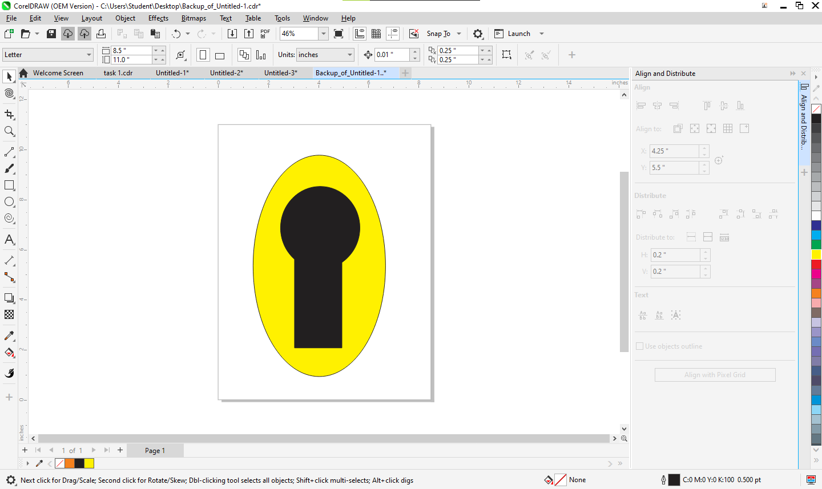

Task 2: Create a Crescent Moon (Using Trim)
- Task Description: Create a crescent moon shape using two overlapping circles.
- Steps to Execute:
  - Draw a large circle using the Ellipse Tool (F7).
  - Duplicate the circle (Ctrl + C, then Ctrl + V) and offset it slightly over the original circle.
  - Select both circles using the Pick Tool.
  - On the Property Bar, click Trim.
  - Move the cutting circle aside to reveal the trimmed crescent shape.
- Tool Used: Trim
- Tool Purpose: Cuts away overlapping portions of an underlying shape using an upper target shape.
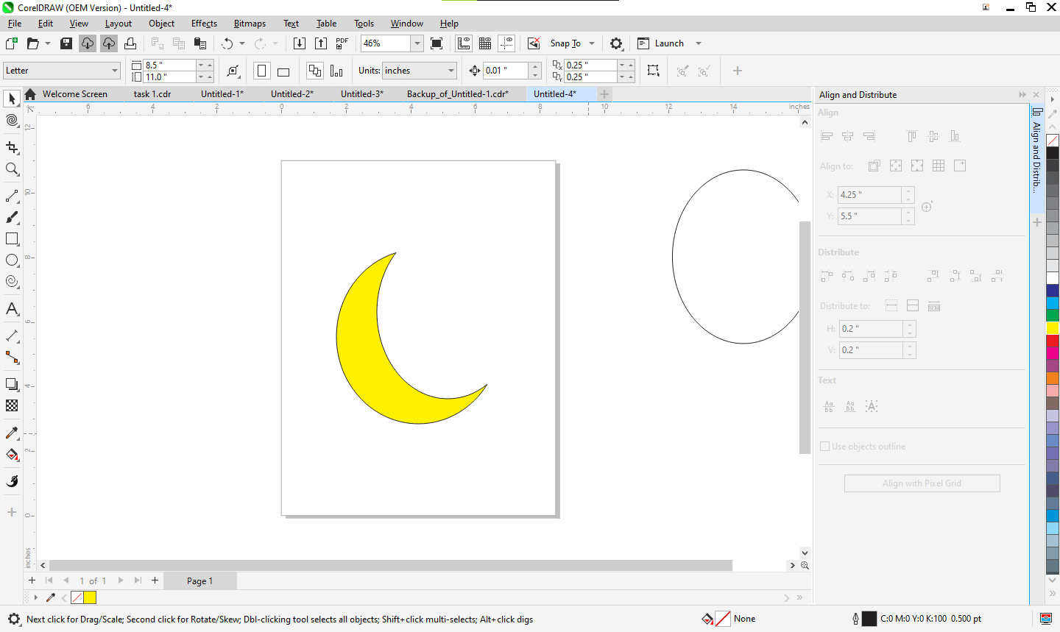

Task 3: Create a Shield or Badge Shape (Using Weld & Intersect)
- Task Description: Build a heraldic shield structure using a rectangle and a triangle, then extract an inner emblem using Intersect.
- Steps to Execute:
  - Draw a rectangle and an inverted triangle; align the triangle at the bottom of the rectangle.
  - Select both shapes and click Weld to create a unified outer shield outline.
  - Place a smaller shape (e.g., star or circle) over the center of the shield.
  - Select both the shield and inner shape, then click Intersect to extract the overlapping badge emblem.
- Tools Used: Weld & Intersect
- Tool Purpose: Weld merges outer boundaries into a single shape, while Intersect creates a new object out of the overlapping central region.
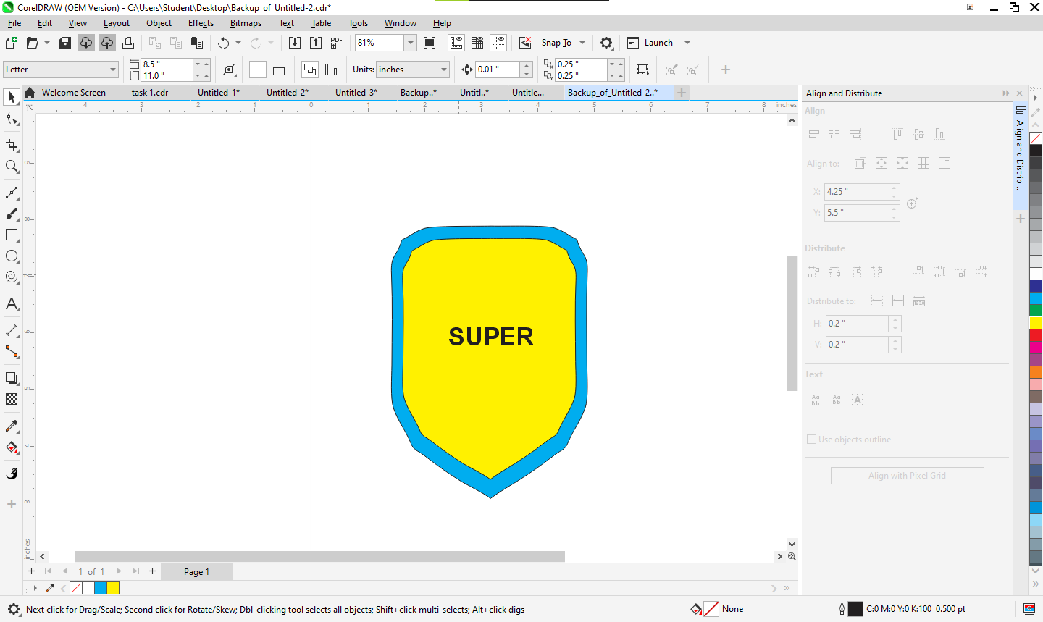

Task 4: Build a Teddy Bear Character (Comprehensive Exercise)
- Task Description: Construct a complete teddy bear character by applying all four shaping operations (Weld, Trim, Combine, Intersect) in sequence.
- Steps to Execute:
  - Stage 1 (Combine & Assembly): Draw circles for the head, ears, muzzle, torso, and limbs. Use Combine (Ctrl + L) for inner ear details.
  - Stage 2 (Weld): Select the head, ear bases, torso, and arm/leg shapes, then click Weld to form the bear's primary body silhouette.
  - Stage 3 (Trim): Position circular shapes over the ear areas and muzzle section, then click Trim to shape the inner curves cleanly.
  - Stage 4 (Intersect & Refinement): Draw ellipses over the feet/paws and apply Intersect to generate precise, aligned footpads. Apply color fills to complete the bear design.
- Tools Used: Weld, Trim, Intersect, Combine
- Tool Purpose: Combines multiple operations to build complex, multi-layered vector character illustrations from basic geometric primitives.


